Question 1

To determine which segment is the most valuable, purchase data was looked at on two levels: on aggregate and per capita. Aggregate data presents an understanding of the size of the magnitude of the entire segment while per capita presents a picture of how much an individual member of that segment can be expected to spend.

Looking only at users who at least qualified for a segment within our purchasing data we see that on average, customers who have bought at least one item from Best Buy (referred to henceforth as Best Buy moving forward) spend the most per customer followed by customers who have made at least one holiday purchase (henceforth referred to as Holiday) and customers who own at least one Status Indicator Sm device (referred to henceforth as Status Indicator Sm).

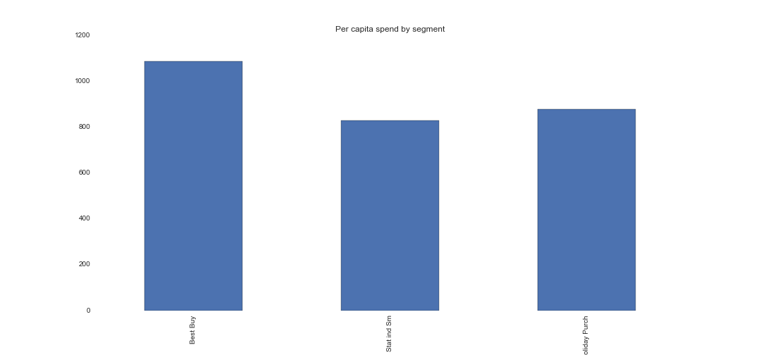

While Best Buy looks to be the clear winner at the per capita spend, the total volume shows the true market size of each of the customer segments and Holiday purchasers seem to be by far the largest driver of total sales.

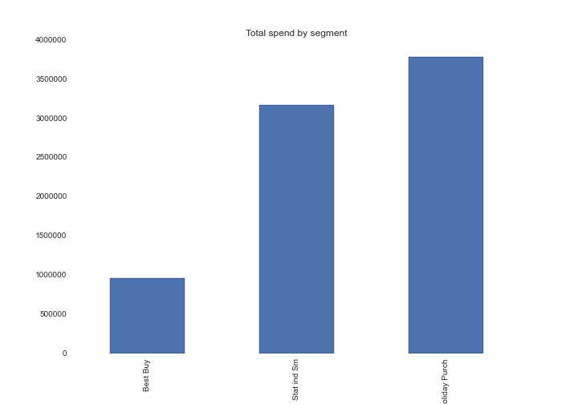

At a 10,000 foot view the story looks clear, but the problem is the way in which the segments have been defined, there is significant crossover between segments. In other words, a individual customer can belong to multiple segments. The extent of the crossover was next examined in a confusion matrix.

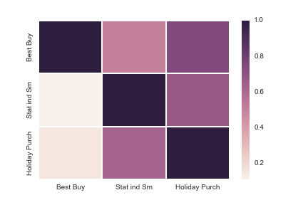

As there is significant crossover between all of the customer segments, a more informative and reliable view of the most valuable customers is attained examining the intersection of the customer segments. These are explicitly defined as Best Buy only segment, Status Indicator Small only segment, Holiday Purchaser only segment, Best Buy and Status Indicator Small only segment, Best Buy and Holiday Purchaser only segment, Status Indicator Small and Holiday Purchaser only segment, and finally customers belonging to all three segments.

The most valuable customer segment is now clear as Status Indicator Small and Holiday purchaser only segments are leading in both the total and per capita spend.

**Total spend by combined segment**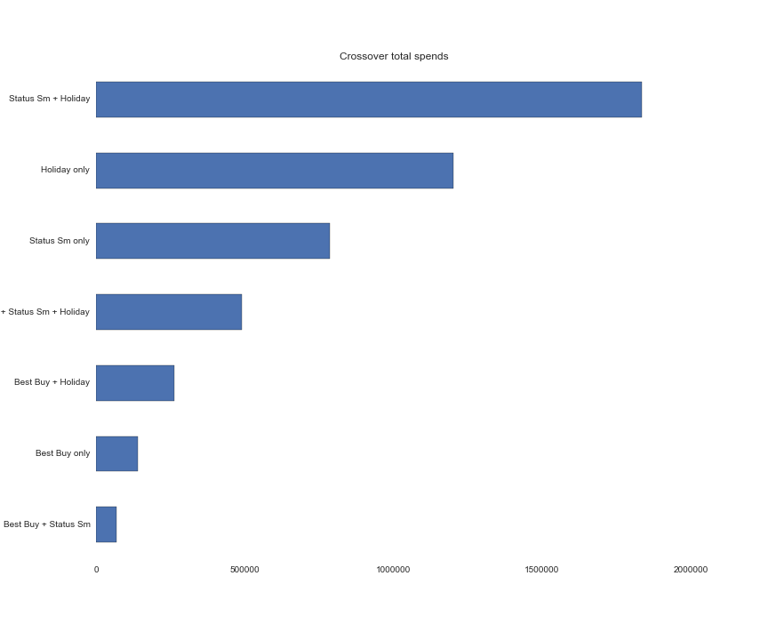

**Per capita spend by segment**

